ADS NOTES
Microstrip Patch Antenna Design

1. Antenna Structure Overview
The designed antenna is a microstrip patch antenna simulated using Advanced Design System (ADS) with the Momentum EM solver.
Layer Stack (Top to Bottom)
- Air
- Patch layer (Conductor)
- Dielectric substrate
- Ground plane (Conductor)
- Air
Both the patch and ground layers are modeled as conductive copper layers.

2. Substrate Selection and Thickness
Substrate Material
- The dielectric material is selected from the ADS material library
- Commonly used materials:
  - FR4 (εr ≈ 4.6)
  - Teflon (εr ≈ 2.15)
  - Alumina (εr ≈ 9.6)
The value of relative permittivity (εr) depends on material availability and design requirements.
Substrate Thickness
- Minimum substrate thickness used: 0.8 mm
- Thickness may be 0.8 mm or multiples of 0.8 mm
Reason:
This value is chosen based on standard PCB fabrication constraints, where 0.8 mm is the minimum commonly available thickness.

3. Ground Plane and Substrate Dimensions
- Ground plane dimensions = 2 × patch dimensions
- Substrate dimensions = ground plane dimensions
This ensures:
- Proper field confinement
- Reduced edge diffraction effects
- More accurate EM simulation results

4. Conductor Properties
- Material: Copper
- Thickness: 0.018 mm (18 µm)
This value corresponds to standard copper cladding thickness used in PCB manufacturing.

5. Frequency Plan Setup
- Frequency sweep type: Linear
- Frequency range: Defined around the antenna’s operating band
- Number of frequency points: Odd number (e.g., 51 or 101)
Why odd number of points?
- Ensures that the center frequency is exactly sampled
- Provides symmetric frequency distribution around the operating frequency
- Improves interpretation of S-parameter results

6. Feeding Technique and Impedance Behavior
Microstrip Line Feeding
- The antenna is excited using a microstrip line feed
- Feed width and height are carefully chosen for impedance matching
Impedance Variation
- Input impedance is minimum at the center of the patch
- Input impedance increases as the feed point moves away from the center
This behavior is used to achieve impedance matching without additional matching circuits.

7. Impedance Matching Criterion
Impedance matching is evaluated using the reflection coefficient (S₁₁).
Matching Condition
- If S₁₁ < −10 dB, the antenna is considered well matched
- If S₁₁ > −10 dB, impedance mismatch exists
Matching Method
- Impedance matching is achieved by:
  - Adjusting the feed position
  - Modifying the microstrip feed dimensions

8. Role of Air Medium
- Surrounding medium is modeled as air
- Characteristic impedance of free space:
Z₀ = 377Ω
Air is used to:
- Accurately model radiation behavior
- Avoid artificial boundary effects

9. Performance Evaluation Parameters
The antenna performance is evaluated using:
- Reflection coefficient (S₁₁)
- Smith chart
- Radiation pattern
- Gain and directivity (if required)

10. Key Takeaways
- Patch and ground are both conductors
- Substrate thickness is chosen based on fabrication feasibility
- Feed position plays a critical role in impedance matching
- −10 dB reflection coefficient is the standard matching threshold
- ADS Momentum solver provides accurate EM-based antenna analysis

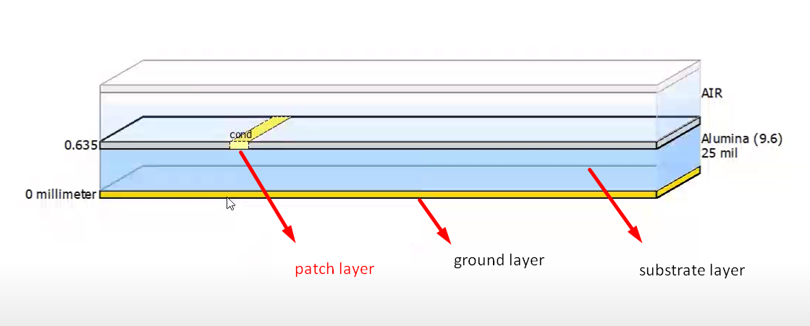

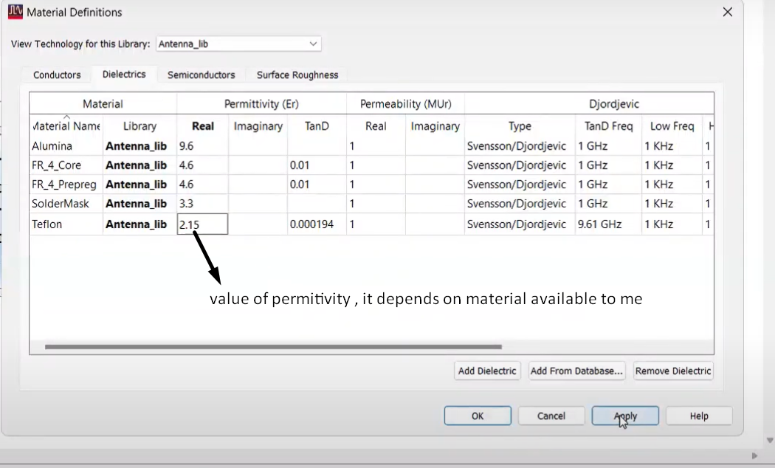
- Patch and ground both are conductor.

- Why the thickness of substrate layer is multiple of 0.8 mm? Bcz thickness of fabcrication pcb layout is minimum 0.8 mm.
- Airpatchsubstrategroundair
- Dimension of Ground =2*patch dimension
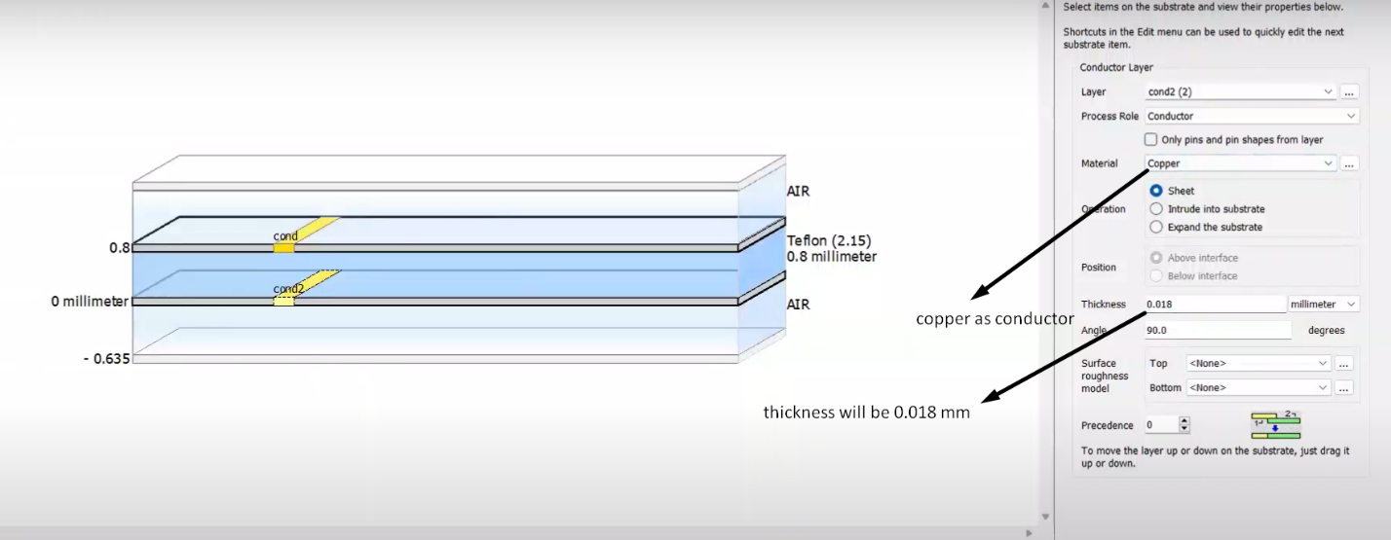
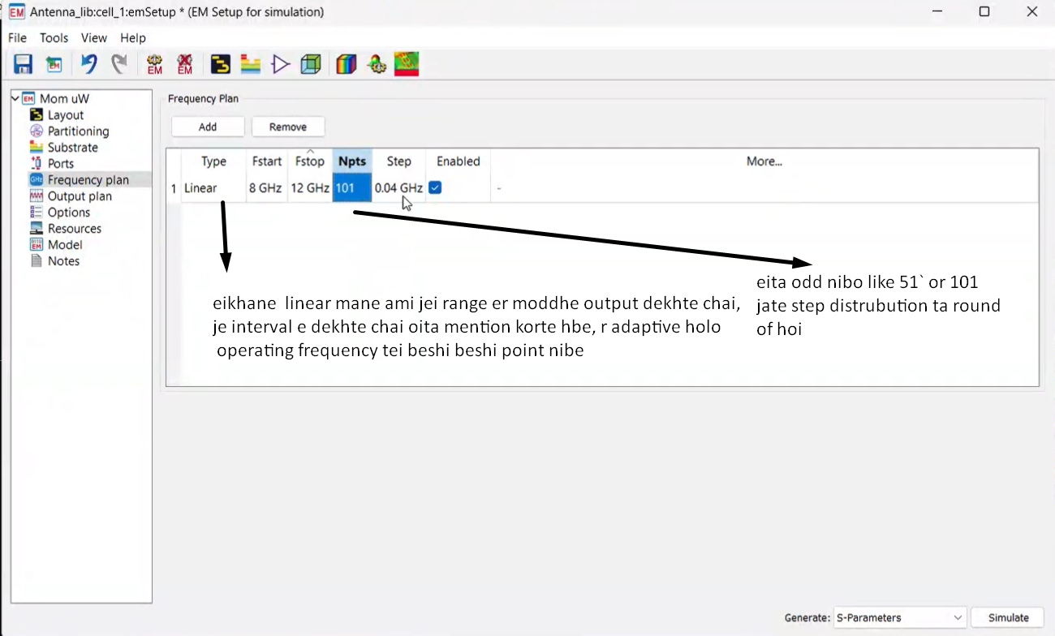
- Dimension of substrate = dimension of ground

- Impedence matching hoise kina check korbo reflection coefficient diye -10db er beshi ashle matched
- Air er impedence 377 ohm. Patch er center theke joto dure jawa jai, impedence barte thake
- -10 db er niche namaite chaile pin position change kore impedence matching korate hbe
